**U.S. Department of Energy (DOE)  
Clean Energy to Communities (C2C) Program**

Summary of Technical Assistance (TA) Support

|  |
| --- |
| Marker with solid fill |
| Icon  Description automatically generatedBuildings |
| Icon  Description automatically generatedClean Power |
| Climate Mitigation and Resilience |
| Cross-Sectoral Justice |
| A picture containing text, clipart  Description automatically generatedJobs and Economic Development |
| Icon  Description automatically generatedMobility |

**Phoenix, Arizona**

TA Scope

From April through October 2023, the National Renewable Energy Laboratory (NREL) provided technical input on the best practices for the utility-scale procurement process including approaching, developing, and completing utility-scale solar procurement. Activities in this work included determining the best procurement approach, developing guidance on a procurement plan for Phoenix, and providing a presentation on the pros, cons, and process of entering a virtual power purchase agreement.

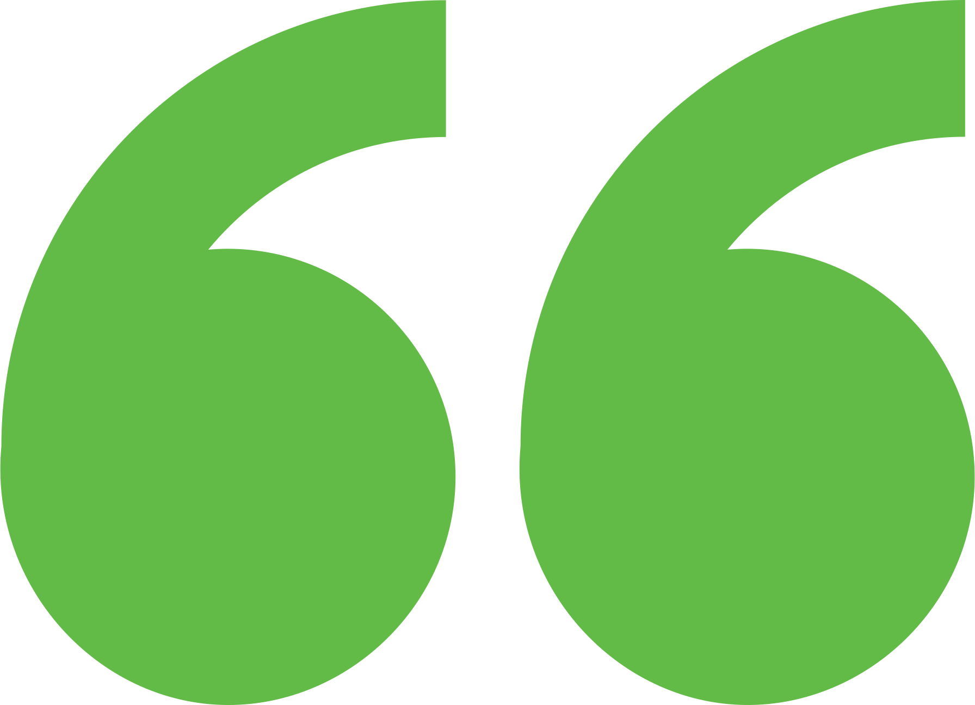 Impact

The city is also participating in the C2C June 2024 Procurement peer-learning cohort. This work will inform Phoenix’s path forward to procuring large-scale solar to meet their 2030 goals.

Background

Photo goes here.

*Delete this box before publishing.*

**Background**

Ann Arbor is a city of approximately 122,000 people located in southeast Michigan. The city and its residents are leaders in sustainability and climate action. Their A2ZERO Climate Action Plan outlines their just transition pathway to community-wide carbon neutrality by 2030. With equity as a focus, they are implementing strategies to improve home energy efficiency (EE) and electrify appliances. Toward this, the city wants to explore community geothermal heating and cooling to serve a variety of building types including rental and affordable housing. The city has applied to DOE’s Geothermal Heating and Cooling Design and Deployment program and garnered the support of City Council to pursue these projects, but they need to understand the concept’s feasibility in order to make a “go, no-go” decision.

The City of Phoenix wanted to understand what opportunities are available to develop utility-scale solar on city land in support of their goal to meet 100% of city operations with clean energy by 2030. Physical power purchase agreements are not allowed in Arizona, so they want to understand opportunities to utilize city-owned land and financial models. Initially, NREL thought this might be a high-level road mapping activity; assuming the city had already done its emissions accounting, NREL could identify property and ownership scenarios to meet their target. The participation of the City of Phoenix in utility-scale renewable energy projects would be crucial to achieving its energy goals. The utilization of land owned by the city, location, utility territory, and financial model, among other considerations, would be some of the upcoming decision points the City of Phoenix would need assistance with.

Expert Match Team

**Alexandra Kramer**  
Community Lead, Main Expert Match Point of Contact, NREL

**Sika Gadzanku**  
C2C Expert Match Program Manager, NREL

**Sushmita Jena**  
Researcher, Procurement Expert, NREL

Community Team

**Carlos Aguiar Hernandez**  
Energy Manager

For more information, visit:  
**energy.gov/eere/clean-energy-communities-program**

August 2024